**REPORT MAY 18**

|  |  |  |  |
| --- | --- | --- | --- |
| **Date:** | **18 MAY 2020** | **Name:** | **Niharika Narayana.L** |
| **Course:** | **TCSION CARRIER EDGE** | **USN:** | **4AL17EC062** |
| **Topic:** | **COMMUNICATION TO IMPRESS** | **Semester**  **& Section:** | **6th SEM B** |
| **Github**  **Repository:** | **Niharika Narayana.L** |  |  |

|  |
| --- |
| **FORENOON SESSION DETAILS** |
| **Image of session** |
| **Report –**  **Communicate to Impress- Communication Involves :**  **1.Intanation 2.Body Language 3.Facial Expression**   1. **Non-Verbal Communication Devices**   **Objectives :**   * + **Importance of Communication**   + **Process of Communication**   + **Barriers od Communication**   + **Distinguish between verbal and Non Verbal Communication** |

* **Use communication Effectively**

**Why Communication Skill ?**

**If you Improve your Communication Skill,I guarantee you that you will earn fifty percent more money over your Lifetime**

**-Warren Buffett**

**Importance of Communication :**

* **Give Information**
* **Persuade**
* **Express Need**

**Types of Communication :**

* **Verbal**
* **Non-Verbal**
* **Visual**
* **Written**

**Process of Communication :**

**Sender-> Encoder -> Channel -> Decoder -> Receiver**

**Effective Communication : Do’s**

* **Maintain Eye Contact**
* **Dress for the Occasion**
* **Speak with Clarity**
* **Right tone of Voice**
* **Correct Posture**
* **Positive Facial Expression**

**Avoid**

* **Checking Phone while Conversation**
* **Dressing Shabbily**
* **Fumbling,Using too many filter Words while Talking**
* **Speaking Rudely**

**Deliver Presentation with Impact :**

* **Create a Attractive Presentation**
* **Engage the Audience**
* **Handling Questions**

**Effective Presentation**

* **Formal Conference**
* **Knowledge Transfer**
* **Team Meeting**
* **Brain Storming**

**Formal Conference :**

* **Decide wether to us the podium or not**
* **If it is large audience MIcrophone Will be needed**
* **Check the Working of the Microphone**
* **Use Remote to Navigate Slides**
* **Make sure Formally Dressed**

**Develop Soft Skills for the Workplace :**

* **Explain the Importance of the Soft Skills**
* **Distinguish between Hard and Soft Skills**

**What is Soft Skills ?**

* **Communication**
* **Negotiation Skills**
* **Critical Thinking**
* **Self Confidence**
* **Business Etiquettes**
* **Goal Setting**
* **Team Work**

**Date: 18 MAY 2020 Name:Niharika Narayana.L**

**Course: PYTHON USN:4AL17EC062**

**Topic:**

**S mall Program,Data**

**T ypes,Operations with Data T ypes**

**Semester & Section:6 B**

**AFTERNOON SESSION DETAILS**

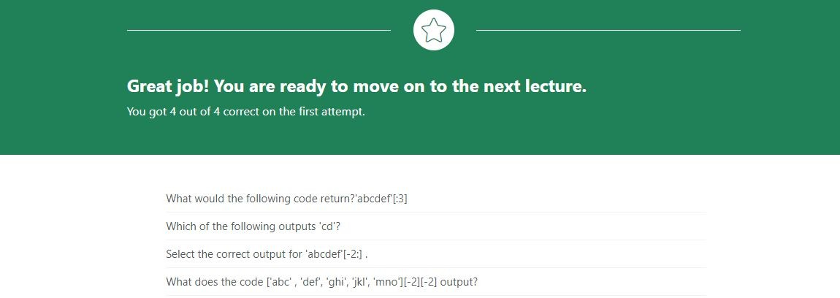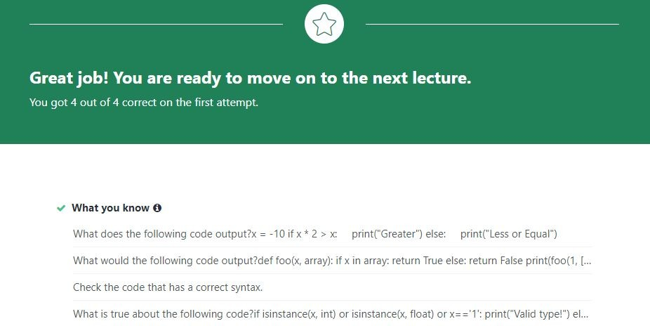

**Image of session**

**Report –**

1. **Course Introduction**
2. **How to Contact Your Instructor**
3. **Preview of the 10 Apps**

**IDE :**

* + **Python 3 and the Visual Studio code IDE is most efficiently used IDE’s.**
  + **There are two ways of executing the python Code,Code can be executed in the Shell or It can be executed by the help of the IDE.**

**First Python Code :**

**>>>import datetime**

**>>>print(datetime.datetime.now())**

**Optimized Code :**

**>>> import datetime**

**>>>print(“The Date and Time Is”,datetime.datetime.now())**

**Variables :**

**import datetime mynow=datetime.datetime.now() print(mynow)**

**variable- can store any kind of data**

**>>>mynumber=10**

**>>>mytext=”hello” print(mynumber,mytext)**

**>>>x=10**

**>>>y=”10”**

**>>>sum1=x+x**

**>>>sum2=y+y print(sum1+sum2)**

**Excercise:**

**x = 3**

**y = 4**

**z = 3**

**s = x+y+z print(s)**

**Excercise : Calculating Maximun student_grades = [9.1, 8.8, 7.5] max_value = max(student_grades) print(max_value)**

**Excercise : Creating Dictionary**

**day_temperatures = {'morning': 5.1, 'noon': 6.1, 'evening': 10.2}**

**Excercise:Creating Toples color_codes = ((1,2,3), (4,5,6), (7,8,9))**

**Excercise : Append Item to List**

**seconds = [1.2323442655, 1.4534345567, 1.023458894]**

**current = 1.10001399445 seconds.append(current)**

**Excercise : Remove item from List**

**seconds = [1.2323442655, 1.4534345567, 1.023458894, 1.10001399445]**

**aseconds = [1.2323442655, 1.4534345567, 1.023458894, 1.10001399445]**

**seconds.remove(1.4534345567)**

**Excercise : Remove three Item From LIst**

**seconds = [1.2323442655, 1.4534345567, 1.023458894, 1.10001399445]**

**seconds.remove(1.4534345567) seconds.remove(1.023458894) seconds.remove(1.10001399445)**

**Excercise : Access and Append**

**workdays = ["Mon", "Tue", "Wed", "Thu", "Fri"] weekend = ["Sat", "Sun"] workdays.append(weekend[0])**

**Excercise : Slicing a List,Last Three letters = ['a', 'b', 'c', 'd', 'e', 'f', 'g'] print(letters[-3:])**